Q1: **Check output of the following commands:**

**1** cmp reginfo.txt personalinfo.txt

**2** diff reginfo.txt personalinfo.txt

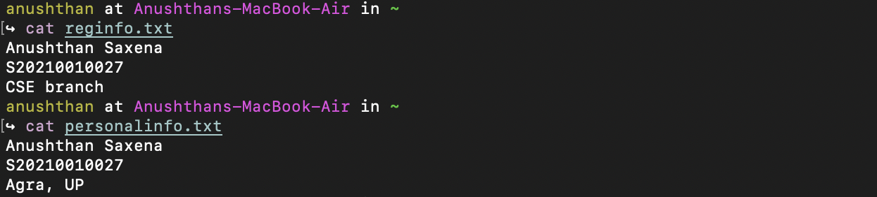

Sol-

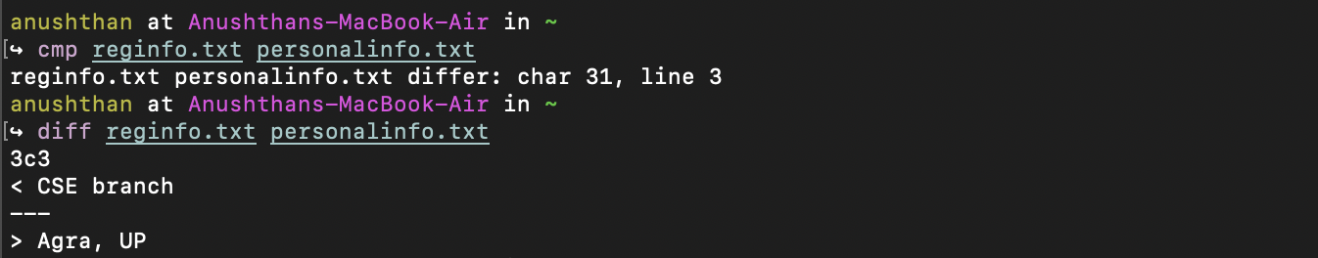

Q2: **Return number of files and directories:**